Cameroon

## Population Data

The data set shows the political stability estimate of the country each year.

## # A tibble: 23 x 5  
## country iso3c date population popCategory5  
## <chr> <chr> <dbl> <dbl> <chr>   
## 1 Cameroon CMR 1996 13970813 small   
## 2 Cameroon CMR 1997 14344449 small   
## 3 Cameroon CMR 1998 14723768 small   
## 4 Cameroon CMR 1999 15112592 small   
## 5 Cameroon CMR 2000 15513945 small   
## 6 Cameroon CMR 2001 15928910 small   
## 7 Cameroon CMR 2002 16357602 small   
## 8 Cameroon CMR 2003 16800865 small   
## 9 Cameroon CMR 2004 17259322 small   
## 10 Cameroon CMR 2005 17733410 small   
## 11 Cameroon CMR 2006 18223674 small   
## 12 Cameroon CMR 2007 18730282 small   
## 13 Cameroon CMR 2008 19252666 small   
## 14 Cameroon CMR 2009 19789919 small   
## 15 Cameroon CMR 2010 20341241 small   
## 16 Cameroon CMR 2011 20906388 small   
## 17 Cameroon CMR 2012 21485266 small   
## 18 Cameroon CMR 2013 22077298 small   
## 19 Cameroon CMR 2014 22681858 small   
## 20 Cameroon CMR 2015 23298368 small   
## 21 Cameroon CMR 2016 23926539 small   
## 22 Cameroon CMR 2017 24566045 small   
## 23 Cameroon CMR 2018 25216237 medium

## # A tibble: 23 x 5  
## country iso3c date popGrowth popGrowthCat5   
## <chr> <chr> <dbl> <dbl> <chr>   
## 1 Cameroon CMR 1996 2.69 high growth rate  
## 2 Cameroon CMR 1997 2.64 high growth rate  
## 3 Cameroon CMR 1998 2.61 high growth rate  
## 4 Cameroon CMR 1999 2.61 high growth rate  
## 5 Cameroon CMR 2000 2.62 high growth rate  
## 6 Cameroon CMR 2001 2.64 high growth rate  
## 7 Cameroon CMR 2002 2.66 high growth rate  
## 8 Cameroon CMR 2003 2.67 high growth rate  
## 9 Cameroon CMR 2004 2.69 high growth rate  
## 10 Cameroon CMR 2005 2.71 high growth rate  
## 11 Cameroon CMR 2006 2.73 high growth rate  
## 12 Cameroon CMR 2007 2.74 high growth rate  
## 13 Cameroon CMR 2008 2.75 high growth rate  
## 14 Cameroon CMR 2009 2.75 high growth rate  
## 15 Cameroon CMR 2010 2.75 high growth rate  
## 16 Cameroon CMR 2011 2.74 high growth rate  
## 17 Cameroon CMR 2012 2.73 high growth rate  
## 18 Cameroon CMR 2013 2.72 high growth rate  
## 19 Cameroon CMR 2014 2.70 high growth rate  
## 20 Cameroon CMR 2015 2.68 high growth rate  
## 21 Cameroon CMR 2016 2.66 high growth rate  
## 22 Cameroon CMR 2017 2.64 high growth rate  
## 23 Cameroon CMR 2018 2.61 high growth rate

## Population trend

The plot shows the population trend of the country.

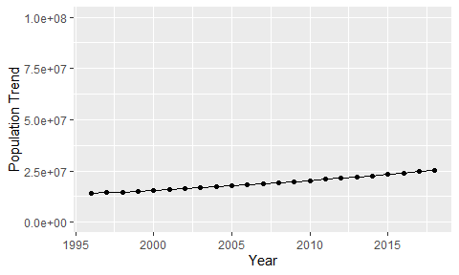

Political Stability Trend

# Population growth graph

The plot shows the population growth rate trend of the country.

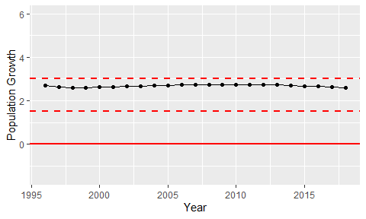

Population Growth Trend